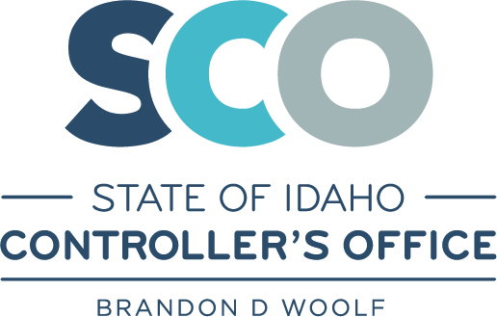

Memo

To: Directors and Fiscal Officers and Assistants

From: Board of Examiners

Date: January 31, 2019

Subject: Update to the State of Idaho Mileage Rate

Today the Internal Revenue Services (IRS) announced a new mileage rate of 57.5 cents, effective January 1, 2020.

At the February 2019 meeting, the State Board of Examiners amended the State Travel Policy as follows:

“If the Federal Mileage rate is set below the current State of Idaho mileage rate, then the State of Idaho mileage rate will automatically decrease to match the Federal rate.”

Due to these changes from the IRS the Idaho State Travel Policies and Procedures policy will be amended from 58.0 cents per mile to 57.5 cents per mile effective January 1, 2020.

Please feel free to contact the State Controller’s Office Accounting helpline if you have any questions. DSAHelpLine@sco.idaho.gov

